

Nomination instructions
2026 Edna V. Folger Outstanding Teacher Award

Award includes
- A monetary stipend
- An individual award for the recipient
- The recipient’s name is added to a permanent plaque at the Columbus Learning Center

Goal
- To renew awareness of the immeasurable influence educators have on their students and to recognize the traditional image of the educator as a community role model

Eligible
- Any full-time, elementary, or secondary classroom teacher or educator working in a Bartholomew County public, private, or parochial school. Classroom, special education, or specials teachers; certified educators; counselors; and administrators are all eligible.

Deadline
- Materials must be received by the IU Columbus Center for Teaching & Learning, 4555 Central Avenue, Columbus, IN 47203 by 4 p.m. on Friday, January 23, 2026.
- Please visit go.iu.edu/columbus-folger-award for complete information and nomination instructions.

The 2026 award will be announced at the
Columbus Area Chamber of Commerce Annual Meeting.

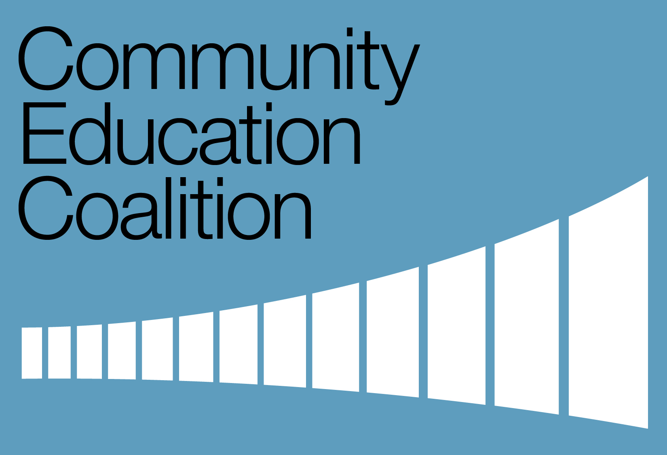

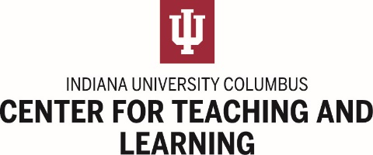
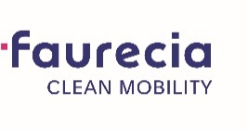
Nomination instructions
2026 Edna V. Folger Outstanding Teacher Award

This award recognizes educators who are role models for others and is not intended as a lifetime achievement award for educators who might be ending their professional careers. Nominations remain active for a minimum of three years. Nominations should be updated each year by the nominator and/or building principal or administrator.

Edna V. Folger Outstanding Teacher Award
Nomination Checklist
Nominee information
Nominee name, school, grades, and subjects taught or areas of expertise
Nominator information
Name, email address, phone number, and relationship to nominee (if any)
Evidence from the building principal or administrator (email or other communication) to confirm he/she is aware of the nomination (REQUIRED)
Letters of recommendation:
Student (current or former) (REQUIRED)
Parent of student (current or former)
Colleague or peer
Within the narrative, describe how the nominee goes above and beyond expectations of a typical educator. Address each of the following unique qualities and qualifications:
Dedication to the profession
Ability to motivate students or staff
Professional competency and ability
Innovation in curriculum or approach to leadership
Relationship to students, parents, and peers
A distinctive philosophy of education
Contributions to the educational community, subject area promotion,
student accomplishments, recognition by peers, educational honors or awards
Examples of the nominee’s leadership as a community role model
Additional references and their contact information
Maximum nomination packet = 10 pages

The deadline for nominations is 4 p.m. on Friday, January 23, 2026. Nominations should be submitted to the IU Columbus Center for Teaching & Learning, 4555 Central Avenue, Columbus, IN 47203. You may also e-mail nomination documents to mvannahm@iu.edu.

For additional information, contact Marsha VanNahmen at the IU Columbus Center for Teaching & Learning, 812.375.7576.

